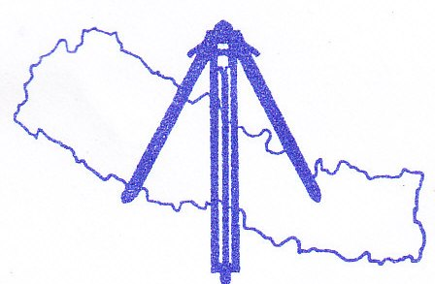
Nepal Institution of Chartered Surveyors
(NICS)
Kathmandu, Nepal
Bid Proposal for Hosting FIG Working Week 2017 in Kathmandu, Nepal
Submitted to

International Federation of Surveyors (FIG)

November, 2013

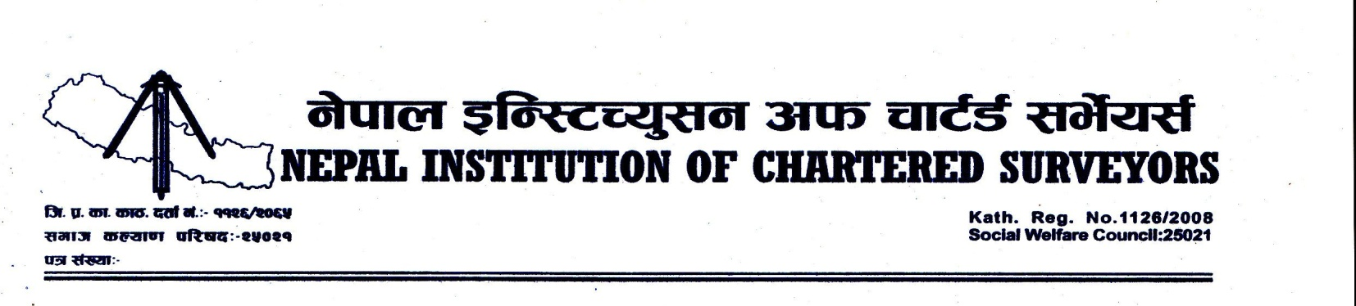November 29, 2013
To
The President
International Federation of Surveyors (FIG)
Copenhagen, Denmark

Dear Sir,
It is with great pleasure and honor that we express our intention to bid for the privilege to host the FIG Working Week 2017 in Kathmandu, the capital city of beautiful Himalayan country in Nepal. This is the second attempt from us, most probably the only organization from South Asian country, to host an event of such kind. Our first attempt was to bid for hosting the week in 2015. Nepal, being the safest and attractive destination for international visitors in South Asia, deserves strong candidacy in this context. Furthermore, strong willingness form the government agencies, professional organizations and universities including Survey Department, the National Mapping Organization of the country, Land Management Training Center, Kathmandu University (School of Engineering), Tribhuwan University (Institute of Engineering), Nepal Surveyors' Association, Nepal Remote Sensing and Photogrammetric Society (NRSPS), and Nepal GIS Society (NEGISS) to support this event has boosted up our confidence to successfully organize the event.
We look forward to be given this immense privilege to host the FIG Working Week 2017 and will do all that is within our capability to ensure 'the best value of money', professionally rewarding, pleasant and memorable experience to all the participants of the event.
Thank you.
Yours sincerely,

Buddhi Narayan Shrestha
President
Nepal Institution of Chartered Surveyors (NICS)

Bid Proposal to Host FIG Working Week 2017
International Federation of Surveyors (FIG) has announced a call for bid to host FIG Working Week 2017. In this context, Nepal Institution of Chartered Surveyors (NICS) has expressed its interest to host the week in Kathmandu, the capital city of Nepal, and has submitted this proposal.

Hosting Organization: Nepal Institution Chartered Surveyors (NICS)
Nepal Institution of Chartered Surveyors (NICS) is an association of licensed surveyors of Nepal licensed under the provision of Article 11(E) of Land (Surveying and Mapping) Act, 1963. It was established in 2008 aiming to contribute in professional development in the country along with professional security of its members. The association is dedicated and determined to follow up the code of conduct, norms, standard and specification set by the concerned government department and organization. Furthermore, NICS is the only professional association that is a member association of International Federation of Surveyors (FIG) in Nepal.

The Country Context
Federal Democratic Republic of Nepal is a landlocked Himalayan country in South Asia, surrounded by China in the North and India in the East, South and West. The country has the area of 147,181 Km². Preliminary result of the census 2011 shows the population of the country as 26.6 million. The country is in the stage of restructuring. Administratively, the country is currently divided into 5 Development Regions, 14 Zones, 75 Districts, 58 Municipalities/ 3913 Village Development Committees. The country has heavenly countryside. It has multi-lingual, multi-ethnic, and diverse culture. The country is famous for Mt. Everest and the birth place of Lord Buddha. There are about 5000 surveyors practicing in the government and private sector in the country.

Rationale of Hosting FIG Working Week in Nepal
Nepal is the safest destination for international visitors in South Asian region. Even during the time of a decade long violent conflict in the country that lasted till 2006, it was a safe place to visit for international visitors. The country hosted 23rd Asian Conference on Remote Sensing (ACRS) in 2002 with grand success, at the time when the country was suffering from the violent conflict. After the reinstatement of peace in 2006, the country is progressing towards socio economic developing of the country. The country is not only a safe place for visit but also a country of attractive touristic destination. On the other hand, no any FIG event has been conducted in South Asian Region until now. Therefore, the country deserves sufficient rationale to host the event.

Introduction to the Hosting City, Kathmandu
Kathmandu is the capital city of Nepal. The city is the largest metropolitan city of the country. The city stands at an elevation of approximately 1,400 metres in the bowl-shaped valley in central Nepal surrounded by four major hills, namely: Shivapuri, Phulchowki, Nagarjun and Chandragiri. Kathmandu valley is part of three districts, Kathmandu, Lalitpur and Bhaktpur districts. The city is the nerve centre of the country’s economy. With the most advanced infrastructure among urban areas in Nepal, Kathmandu's economy is tourism centric. The city’s rich history is nearly 2000 years old, as inferred from an inscription in the valley. It has historic temples with pagodas, temple of living goddess Kumari, attractive places, historical palaces, etc. The climate of the city is fairly pleasant. Average temperature in the months of April/May is about 12 ⁰C to 28 ⁰C, which is one of the peak touristic seasons of the country.

Supporting Organizations
Following organizations have shown their strong willingness to support the event:
- Survey Department: Survey Department, under the Ministry of Land Reform and Management, is the National Mapping Organization of Nepal. The department is also an affiliate member of FIG. The department is the organization with the largest numbers of surveyors. (www.dos.gov.np )
- Land Management Training Center: Land Management Training Center is also an organization under the Ministry of Land Reform and Management. The center produces surveyor by conducting various kinds of training courses. The center is an academic member of FIG. (www.lmtc.gov.np )
- Kathmandu University, Department of Civil and Geomatics Engineering: Kathmandu University is the first university in Nepal to conduct academic course in Geomatics Engineering in the country. The university conducts undergraduate level courses in Geomatics Engineering and produces about 25 survey graduates each year. The university has launched Master's in Land Administration course since last year, in collaboration with the Ministry of Land Reform and Management of the Government of Nepal. This course is also being supported by the University of Twente, Faculty of Geoinformation Science and Earth Observation, ITC, the Netherlands. (www.ku.edu.np )
- Institute of Engineering, Tribhuwan University: The Institute of Engineering(IOE) was founded in 1930 as Nepal's first technical school and reformed to present shape in 1972. The institute is one of the major wings of the Tribhuwan University, the oldest national university in the country. The institute is producing outstanding engineering technicians and engineers for more than 80 years. The Institute has launched Bachelor of Engineering in Geomatics course since this year. Recently, the institute has organized International Workshop on Advanced Geospatial Technologies for Sustainable Environment and Culture (as an event of ISPRS, Technical Commission VI, Education and Outreach, Working Group 6) in the beautiful city of Pokhara. (www.ioe.edu.np)
- Nepal Surveyors' Association (NESA): Nepal Surveyors' Association is the first government registered professional organization in surveying and mapping domain. It was established in 1991. Any surveyor having at least one year's training on surveying can be a member of this association. Currently, it has more than 2000 members working in different capacities, ranging from assistant surveyors to high level government officials, throughout the country. Involvement of this association in organizing the event will help increasing the national participants in the event.
- The International Centre for Integrated Mountain Development (ICIMOD): The International Centre for Integrated Mountain Development (ICIMOD) is a regional intergovernmental learning and knowledge sharing centre serving the eight regional member countries of the Hindu Kush Himalayas Afghanistan, Bangladesh, Bhutan, China, India, Myanmar, Nepal, and Pakistan – and based in Kathmandu, Nepal. ICIMOD aims to assist mountain people to understand these changes, adapt to them, and make the most of new opportunities, while addressing upstream-downstream issues. The center supports regional transboundary programmes through partnership with regional partner institutions, facilitate the exchange of experience, and serve as a regional knowledge hub. It strengthens networking among regional and global centres of excellence. Overall, the ICIMOD is working to develop an economically and environmentally sound mountain ecosystem to improve the living standards of mountain populations and to sustain vital ecosystem services for the billions of people living downstream now, and for the future. ICIMOD has an experience of organizing different kinds of international level conferences and workshops. (http://www.icimod.org)
- Nepal Remote Sensing and Photogrammetric Society (NRSPS): Nepal Remote Sensing and Photogrammetric Society (NRSPS) is a non-profit organization of scientists and professionals practicing Remote Sensing and Photogrammetry, and is committed to promoting the use of these emerging technologies for the benefit of the society. The society is a member association of International Society of Photogrammetry and Remote Sensing (ISPRS). The society organizes workshops, talk programs and awareness programs at national level.
- Nepal GIS Society (NEGISS): Nepal GIS Society is a non-profit forum of GIS professionals and users in Nepal registered under the Government of Nepal on July 22, 1995. The inception of the Society is attributed to the felt needs of GIS professionals for a common forum for advancing the use and for sharing professional experiences in addition to dedicating to larger mandate of engaging on advocacy for optimized management of spatial data resources among others. Since the establishment the Society, it has been working for the development of GIS awareness activities and its application in the country.

Fee Structure
Fee structure has been proposed as follows:
- International Participants
Early Registration Fees |  |  | Late Registration Fees
Conference | Accompanying Person | Students | Conference | Accompanying Person | Students
USD 600 | USD 250 | USD 200 | USD 800 | USD 300 | USD 250

- Nepalese Participants
Early Registration Fees |  |  | Late Registration Fees
Conference | Accompanying Person | Students | Conference | Accompanying Person | Students
NRs. 10,000 | NRs. 2,500 | NRs. 3,000 | NRs. 12,500 | NRs. 3,000 | NRs. 5,000
Full registration fee and students’ registration fee are planned to include admission to the General assemblies, all technical sessions, exhibition, welcome reception, coffee breaks, and conference stationeries. For the technical and social tours and Farewell banquet participants are to register and pay separately. The fee for social tour in Kathmandu Valley will be approximately about USD 50 per person whereas the farewell banquet will be charged approximately USD 30. Site tour to the most beautiful city of the country, Pokhara, and the birth place of lord Buddha, Lumbini, can be arranged. Interested participant will be requested to register before a week of the event. The cost will depend upon the number of participants. The prices can vary depending upon the number of participants. Furthermore, USD 15 will be included in the registration fee of the International participants for FIG Foundation. Donations for FIG Foundation are always welcome. Free registrations will also be offered as per the FIG decisions and agreements. An amount equivalent to 2% of the early registration fees will be allocated to subsidize the participation or waving the registration fee of presenter(s) of peer reviewed paper(s) from the developing country or under representative group or students. NICS will also explore sponsorship or financial support from the government organizations in the country. The royalties will be shared by NICS and FIG on fifty-fifty basis. The budgetary issues can be further negotiated with the FIG.

Expected Participants
Following is the expectation of participants. However, the expectation does not have any scientific basis.
- International Participants with Full Registration Fee: 500
- Accompanying participants: 50
- International Students: 100
- Local Participants: 500

Venue
The proposed venues for the event are:
- 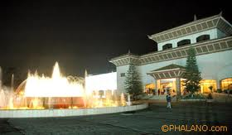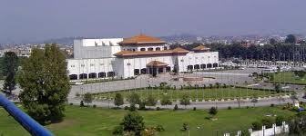Birendra International Convention Center (BICC). This center is located at the center of Kathmandu Valley. Currently, the center is rented by the Constituent Assembly and Legislative Parliament of the country. The center has state-of-the-art facilities for conferences and conventions with sophisticated audio, video, lighting, communications, catering, ventilation and parking facilities. In 2002, 23rd Asian Conference on Remote Sensing (ACRS) was organised in this center. This center meets all the requirements to organize FIG events.
- 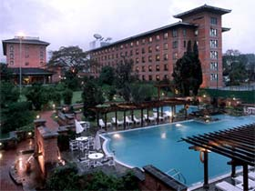Soaltee Crown Plaza. Soaltee Crown Plaza, a five star hotel in the country, can be considered as an alternative venue for the event. The hotel is spread over 11 acres of 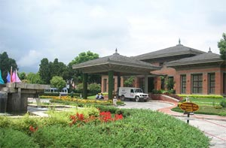space surrounded by manicured gardens and with views of the mountain ranges. The hotel has sufficient facilities to organize international event like FIG Working Week.

Proposed Date
Second Week of April, 2017.

Arrangement during the Working Week
The activities during the working week including opening ceremony, technical conferences, meeting, social tours, exhibitions, social events, closing ceremony will be organized as scheduled by FIG. The organizing committee will make possible best effort to bring the President or the Prime Minister of the country as the Chief Guest of the Opening Ceremony. Details of the program will be developed in consultation with FIG.

Hotels in Kathmandu
Kathmandu has a number of international class hotels to suit every one's fancies and finance. Soaltee Holiday Inn Crown Plaza, Hotel Yak & Yeti, Hotel Everest, Hotel Annapurna, Hotel Radisson, Hotel Hyatt and Hotel Le Meridian are the five star hotels in Kathmandu. The other hotels are Hotel Dwarikas, Summit Hotel, Shanker Hotel, among others. One can also find cheap hotels in the city with affordable accommodation and safety.

Contact Person and Address
Mr. Buddhi Narayan Shrestha
President
Nepal Institution of Chartered Surveyors (NICS)
55 Shabda Marg, Bagbajar
Kathamndu-31, Nepal
Telephone no . +977(1) 4254181
Fax no. + 977(1) 4440766
Mobile. + 977 9841311611
E-mail address. bordernepal@gmail.com

